# **Restore Database**

1. Open Microsoft SQL Server Management Studio, and navigate to **Databases**:  
   
2. Right-click **Databases**, and click **Restore Database**.  In the **Source for restore**section, select **From Device**, and click the browse button:

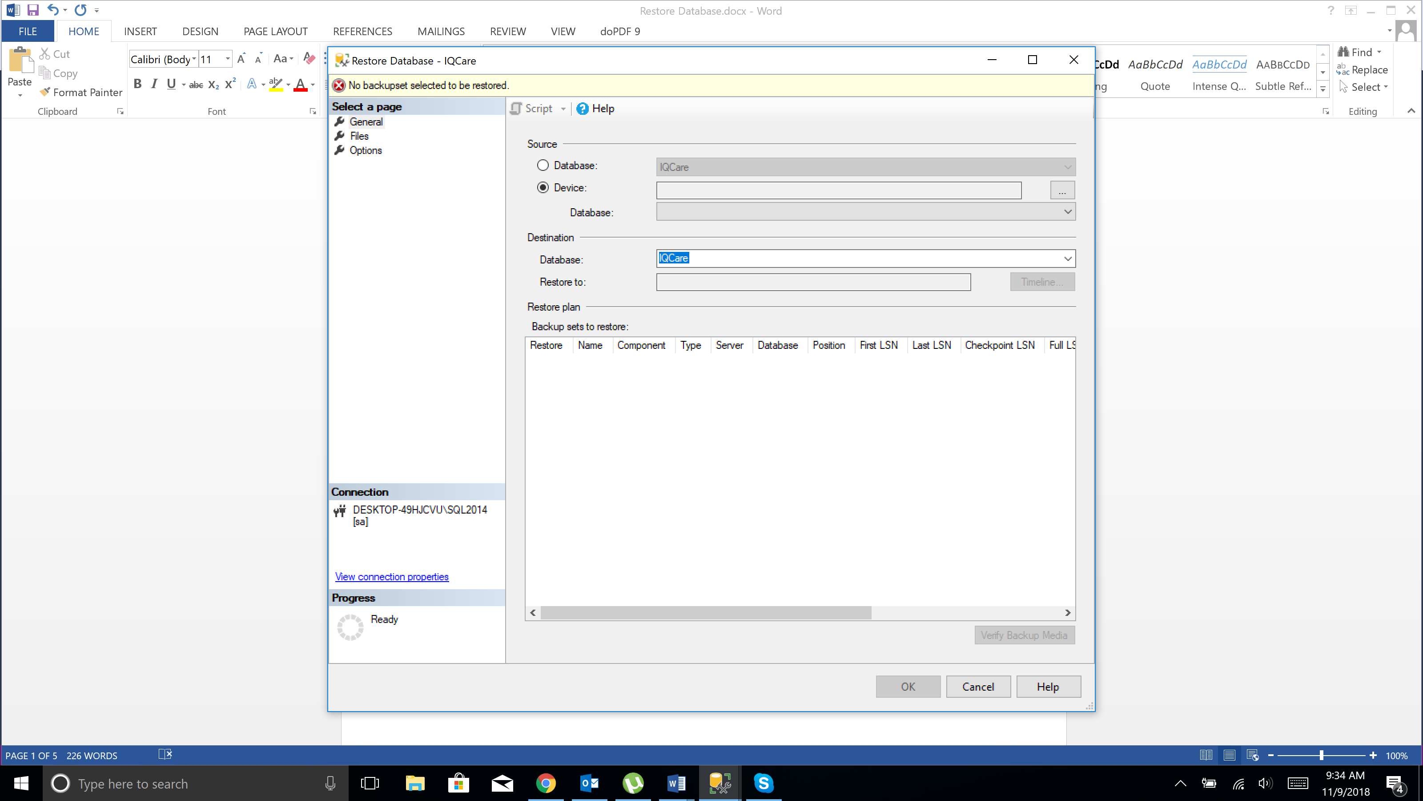

1. Click **Add** in the **Specify Backup** window.

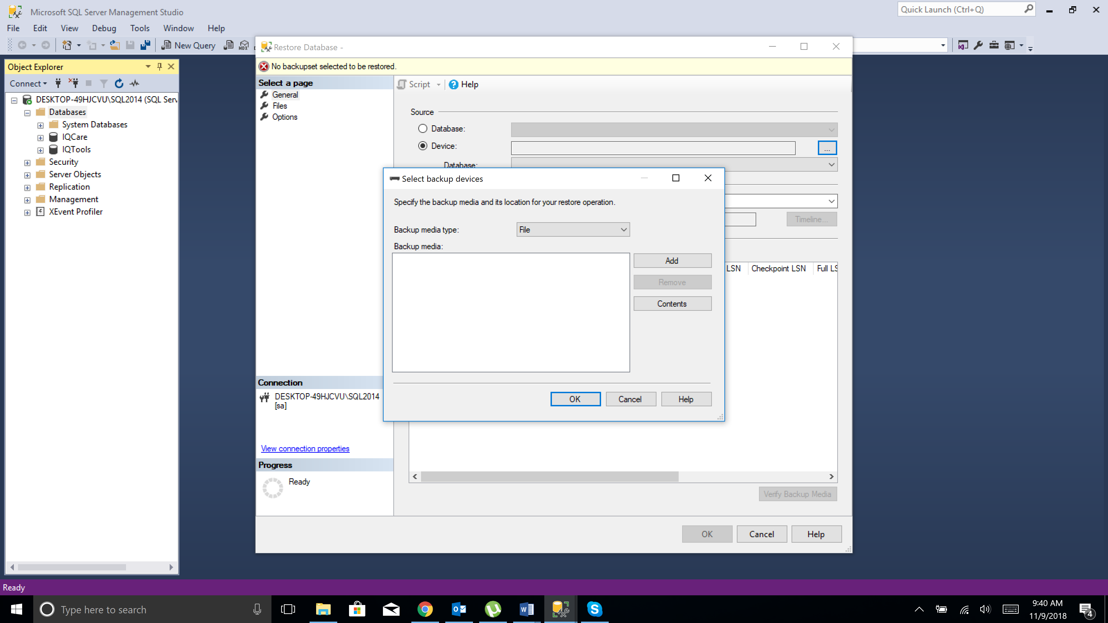

1. Browse to the location of your recently restored flat files. Choose the backup file which should be the first backup file in the list:

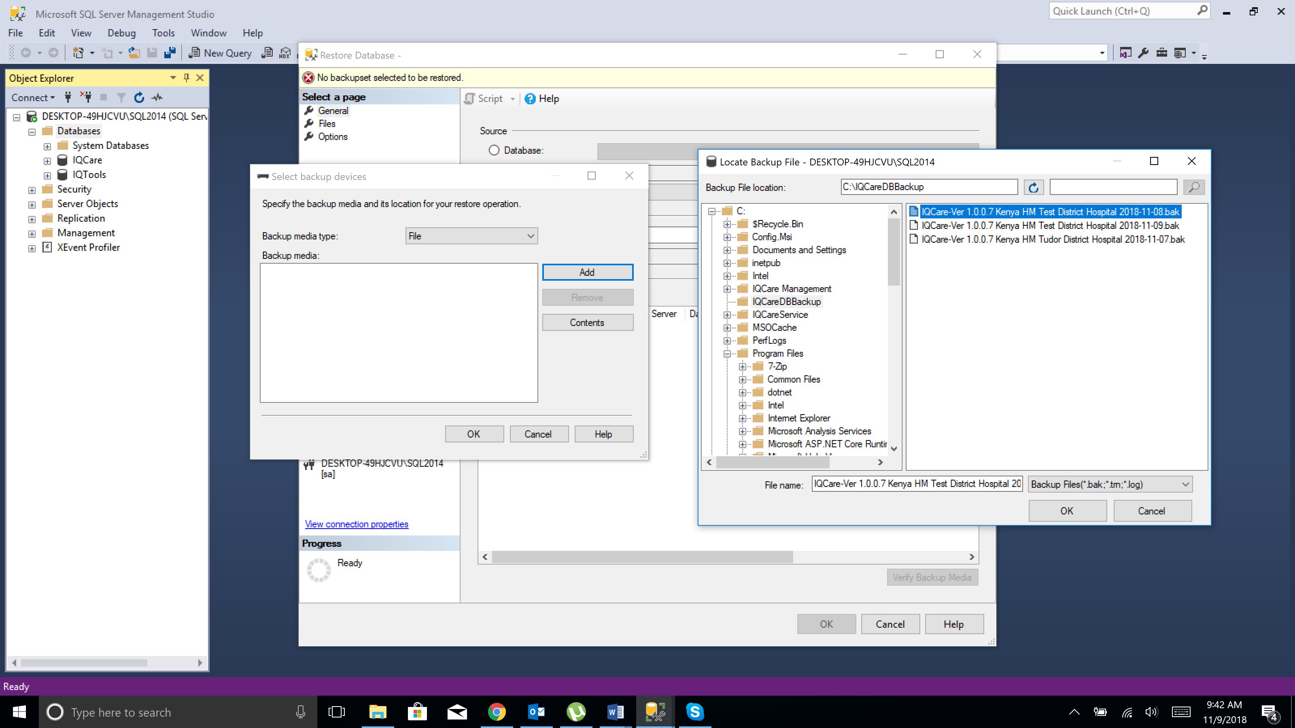

1. Click **OK**; the **Specify Backup**window displays:

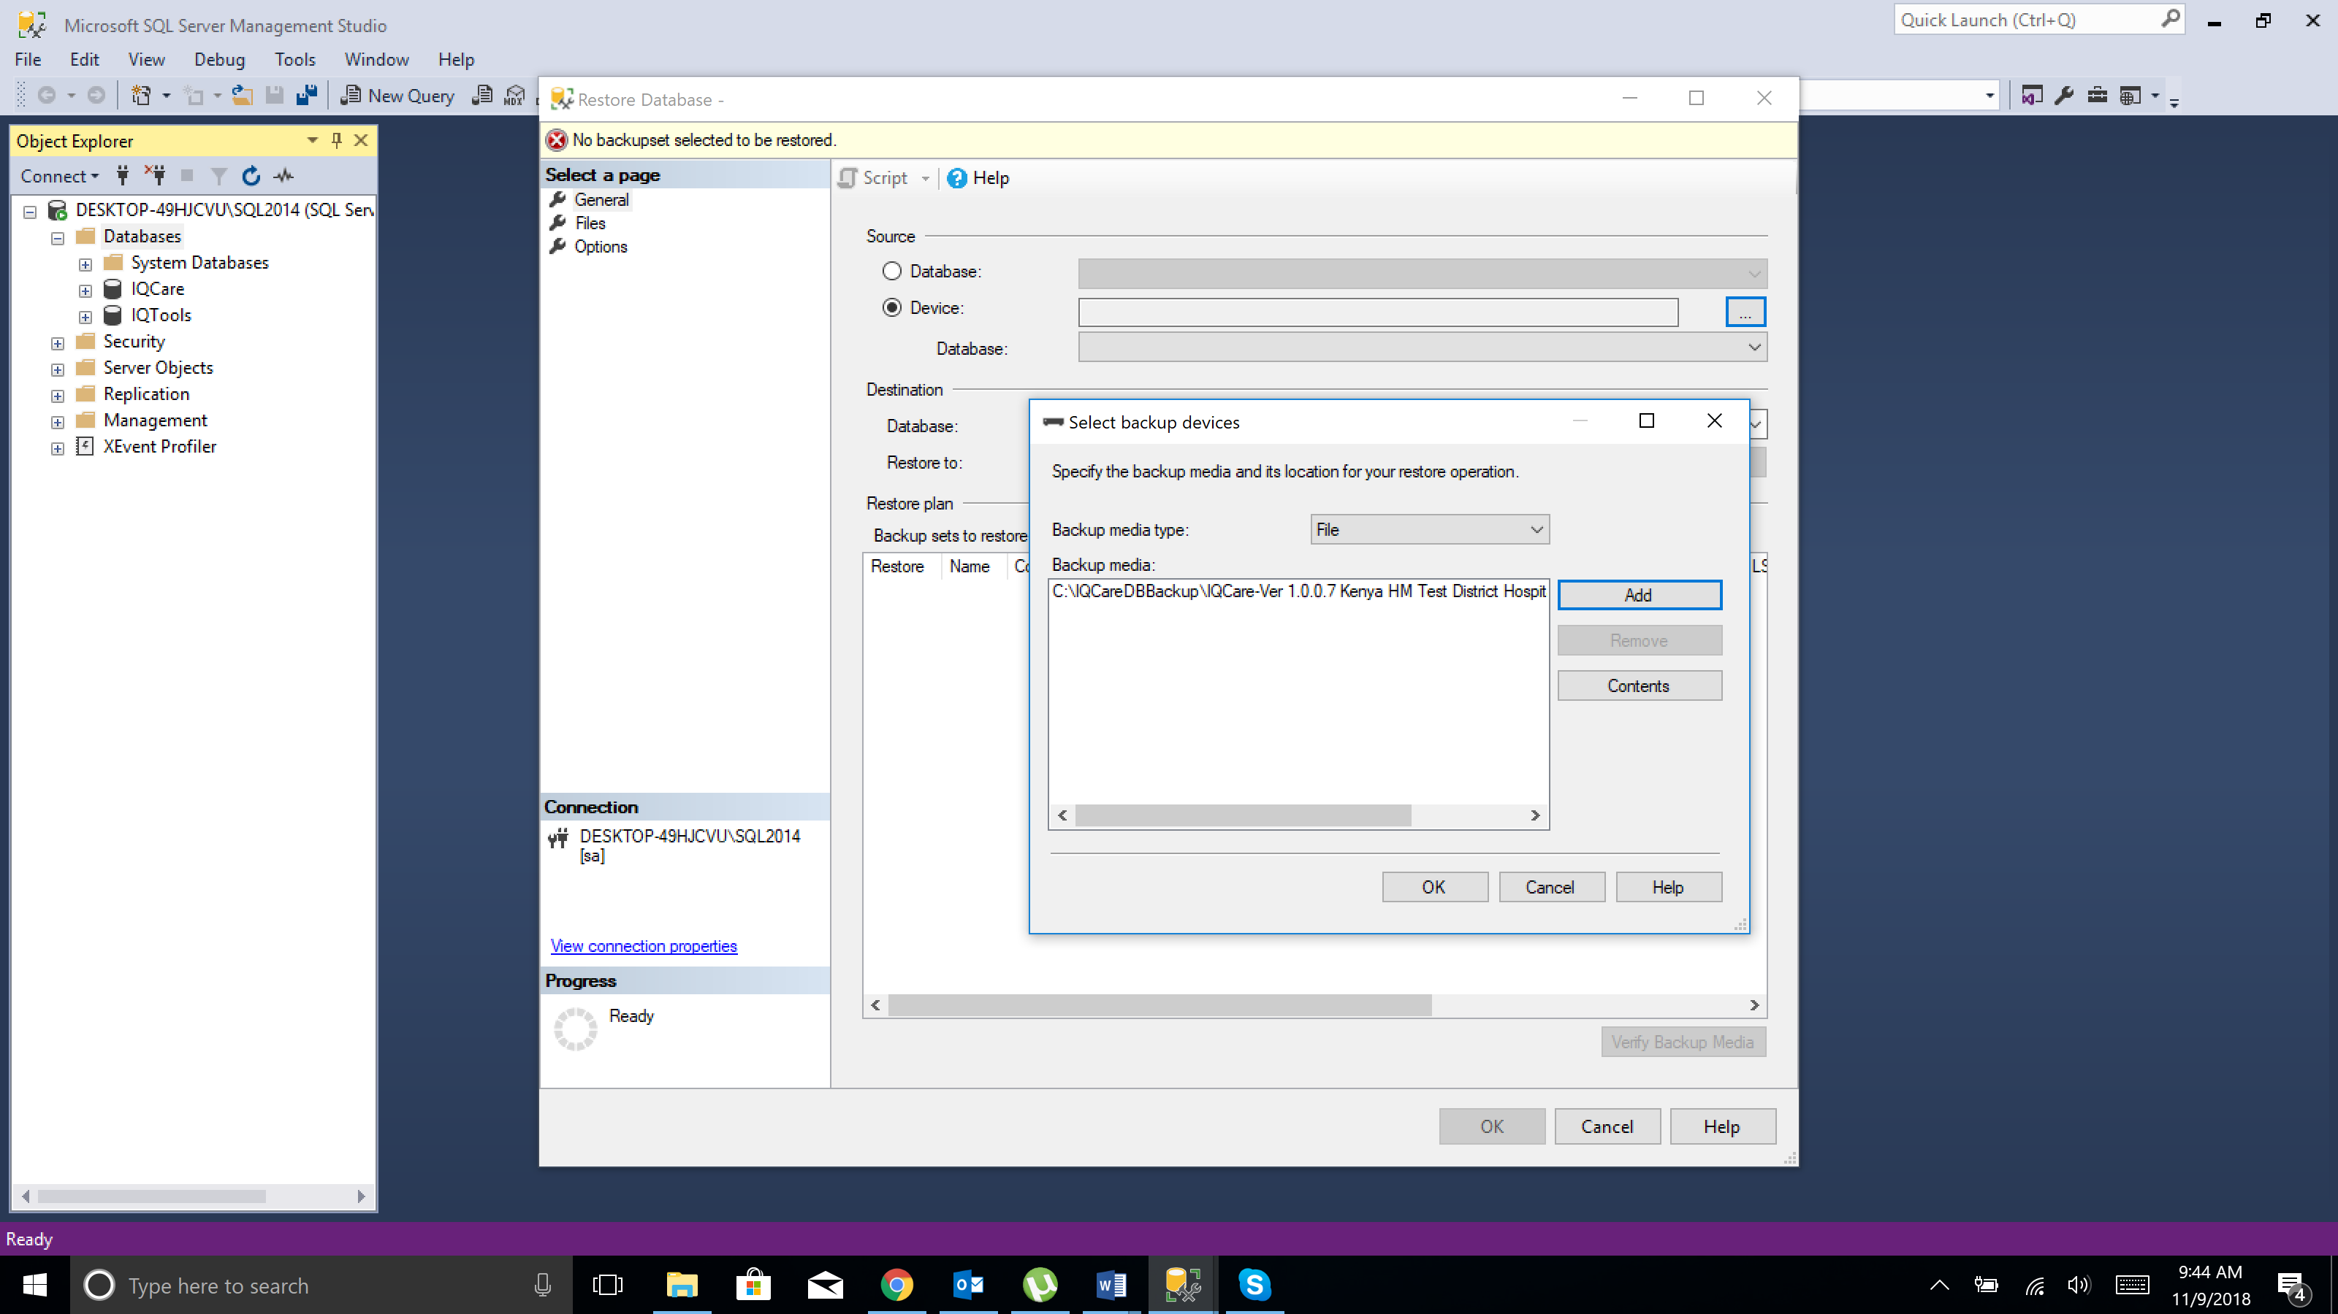

1. Click **OK**.

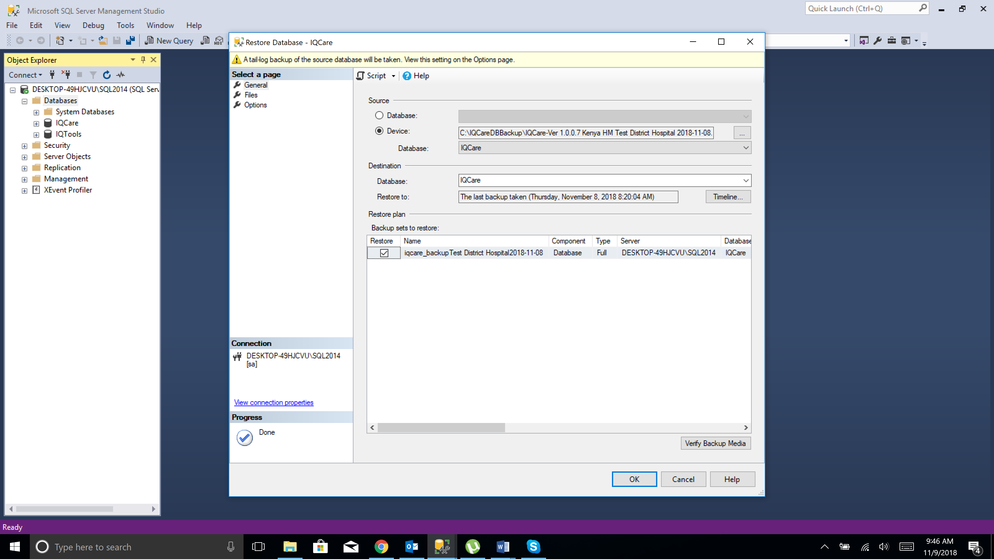

1. In the **Destination for restore** section, enter the database name.

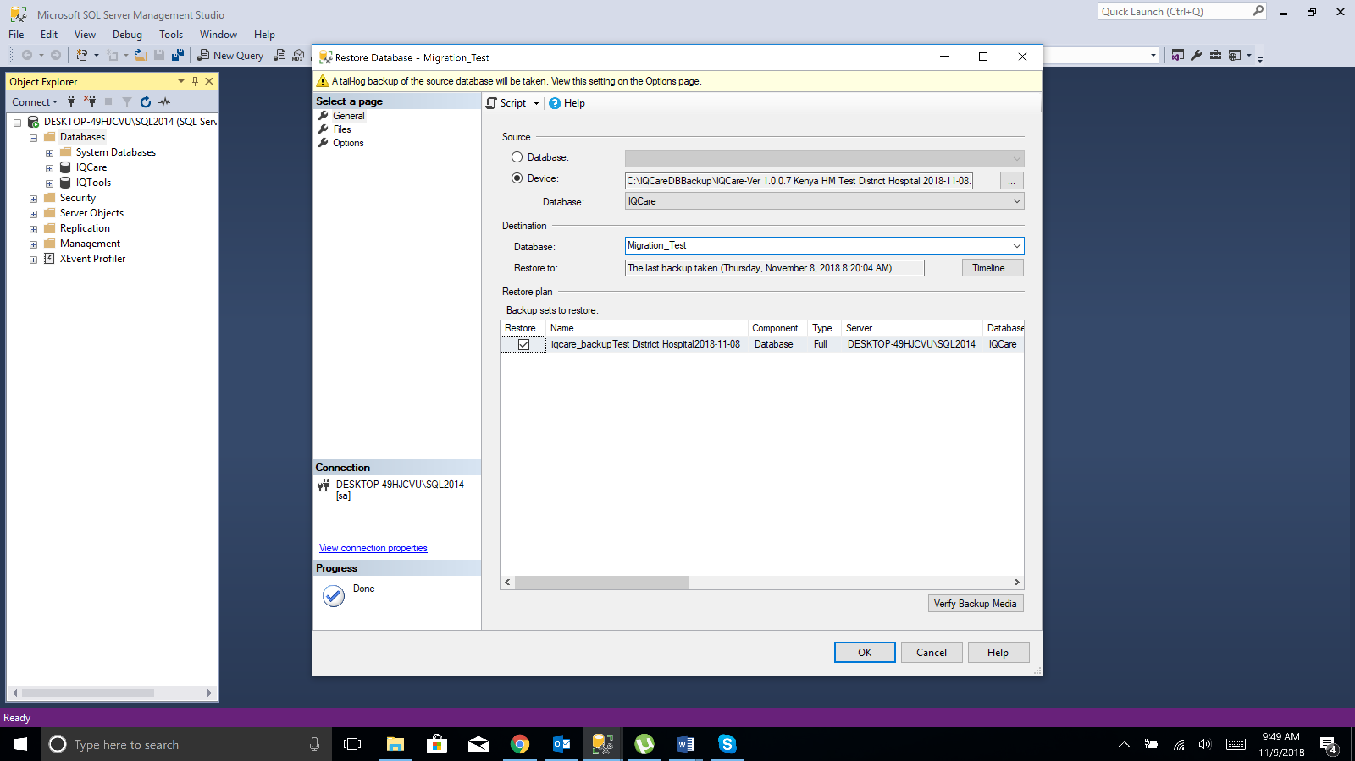

1. In the left pane, click **Options**, and select **Overwrite the existing database (WITH REPLACE)**, and leave the other options unselected the **Restore options**section

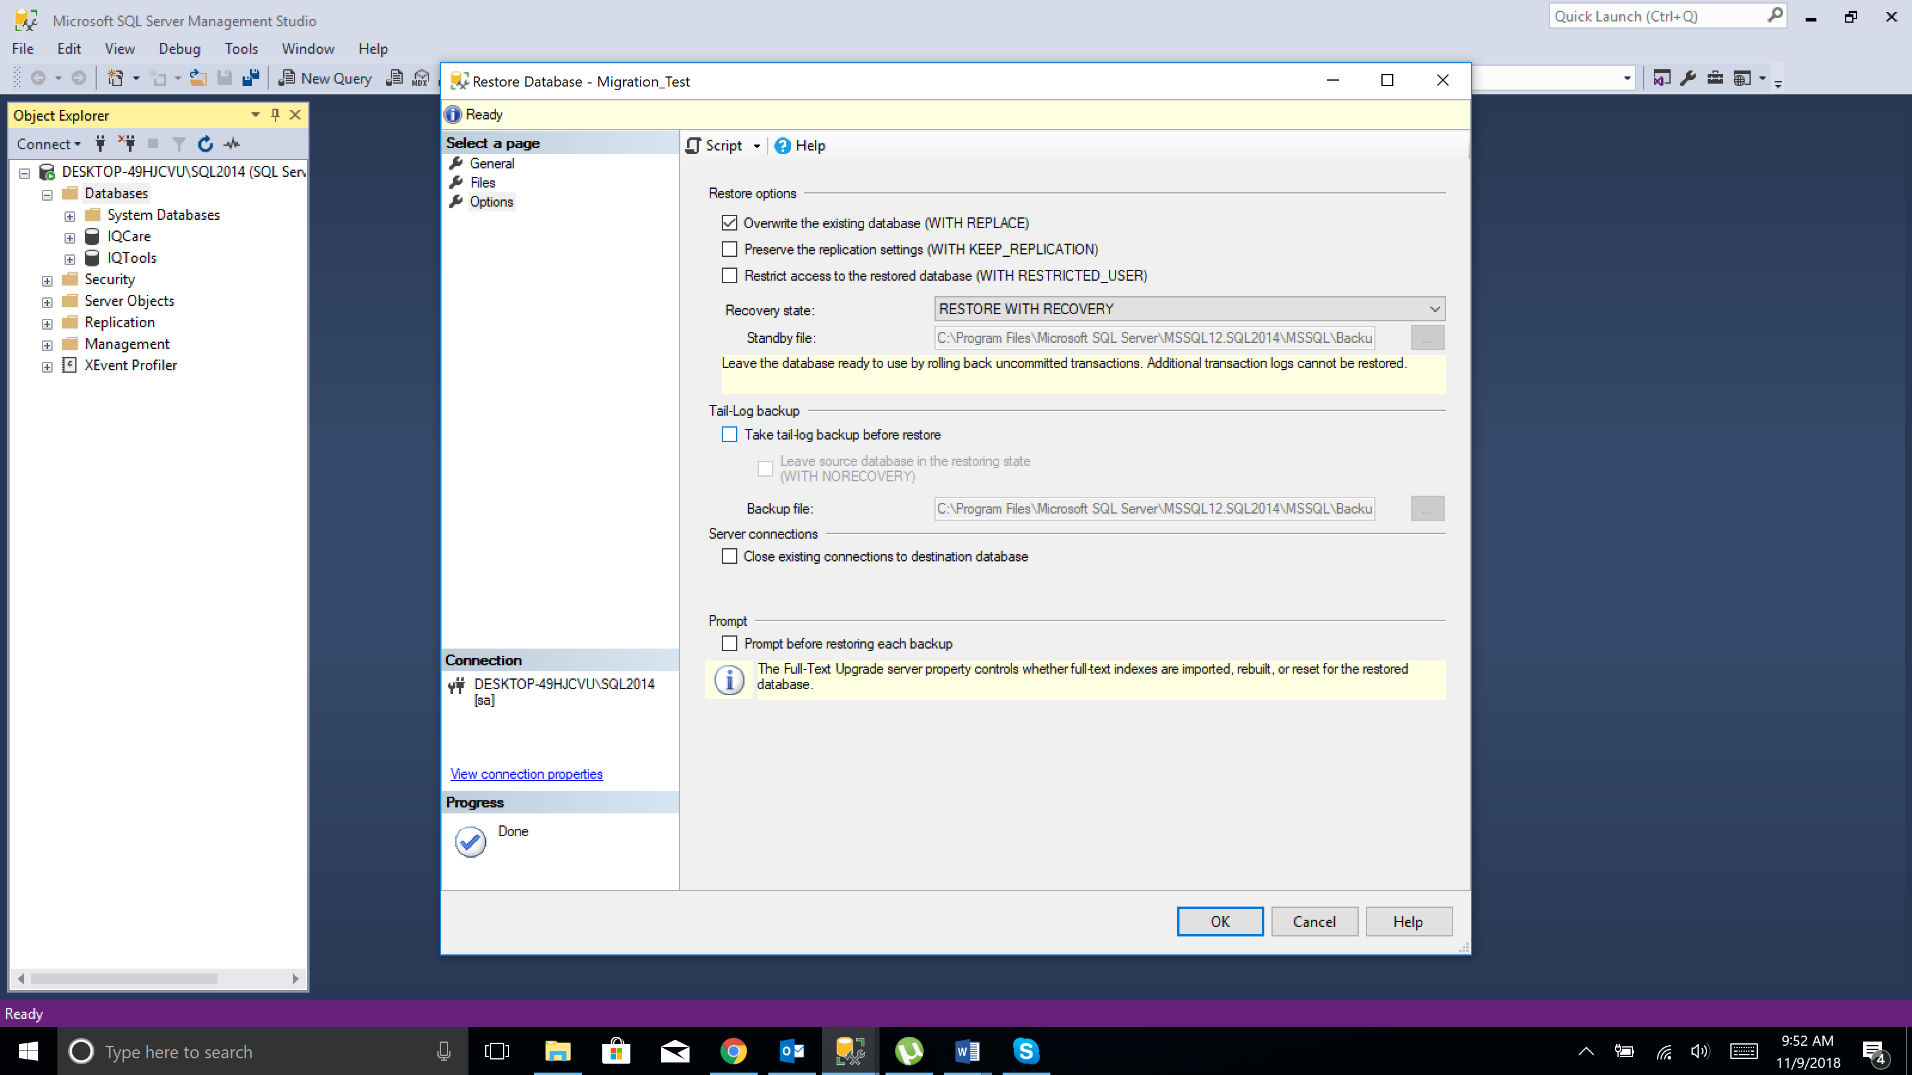

1. Click **OK** to perform the restore.